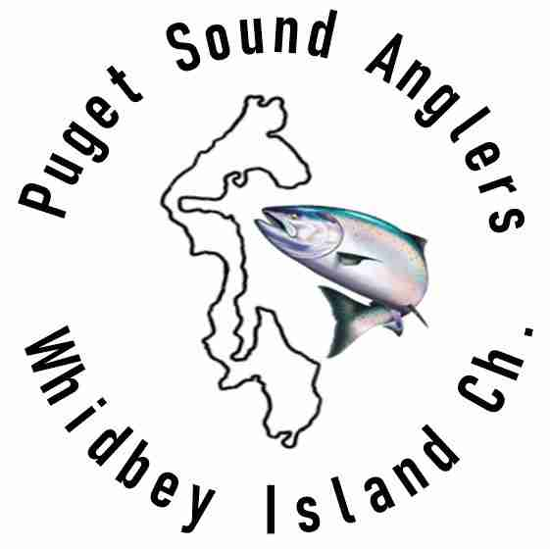

Membership Application

I wish to become a member of the Whidbey Island - Chapter of Puget Sound Anglers.

Please complete a membership application. Fill out the form below and bring to a meeting or mail to the address below.

Annual membership dues are $35 for a single / $40 a family membership (husband and wife). There are several payment options:

- Make your check for $35/40 payable to "Puget Sound Anglers" and mail your check to the address below.

- Make your check for $35/40 payable to "Puget Sound Anglers" or bring cash to one of our regular meetings.

Whidbey Island - Chapter PSA
PO Box 1882
Oak Harbor, WA 98277
Name Date_______ Address
City State Zip_ Cell Phone Home Phone _ E-mail
Boat make & size_ Boat name

